School of Science and Technology
MIDDLESEX UNIVERSITY
EXAMINATION PAPER
Academic Year 2015/2016 (Sample Exam)
CSD3939

Developing Artificial Intelligence
Prof C. Huyck

Time allowed: 3 Hours
Total number of questions: 4 Questions
Instructions to candidates: Answer all questions. Each question carries 25 marks.

Materials provided: Equipment permitted: None

Total number of pages: 3
EXAM PAPER CAN BE REMOVED FROM THE EXAM ROOM
No books, paper or electronic devices are permitted to be brought into the examination room other than those specified above.

Candidates are warned that credit cannot be given for work that is illegible

1. Search and State Spaces
(a) What is the size of the search space for noughts and crosses (tic-tac-toe)? Explain your reasoning.
(6 marks)
Marking scheme:
2 points for having something reasonable
2 points for something relatively close (e.g. 8000)
2 points for reasonable explanation.
Sample answer:
You can start with there being 9 spaces and each can be in 3 states (X,0 or blank). That’s 3^9. You could also say after the start state there are 9 possible first moves, 8 second and so forth. That’s 9! +1. Lots of these are invalid, but that’s a reasonable start. So 9*8*7*6*5*4*3*2*1= 72*42*20*6 =2924*120=8772+1 = 8773. Lots of these can be eliminated by symmetry
(b) What would be a good algorithm for playing noughts and crosses? Explain the algorithm, and you may use its common name.
(6 marks)
Marking scheme:
3 points for a reasonable algorithm. Minimax is the obvious one, but others could work.
3 points for explanation.
Sample answer:
The simple answer is to use minimax. X maximizes and O minimizes. The evaluation function is win lose or draw, and you should be able to go to the end of the space. Therefore, the algorithm should play perfectly. It should never lose, and win if the opponent makes a mistake. If it played itself, it would draw. Minimax looks ahead and in this case to the end of the game. It assigns a value to the final state, and passes those values to the prior state. If the prior state is a maximize level, the value passed up is the highest of the possible option. If it is minimize, it will choose the lowest. The algorithm would play (X) by choosing the maximum value option from the current options.
(c) The travelling salesman problem involves a salesman going to all of the cities but going to each just once. The goal is to travel as little as possible. What is a good algorithm for solving the travelling salesman problem? You can assume that you’ll have around 40 cities. Why is it a good algorithm?
(8 marks)
Marking scheme:
2 points a reasonable algorithm
3 points for exhaustive
3 points for large but not vast space.
Sample answer:
With 40 cities, there are roughly 2^40 paths or 1,000,000,000,000. That’s a lot, but it is possible that it can be exhaustively searched. In particular, using Dijkstra’s algorithm will probably manage this in reasonable times, and it will return the optimal result. Dijkstra’s algorithm expands the best possible paths.

(d) If you had over 100 cities, would you typically be able to find the optimal solution in a reasonable time? What techniques could you use to improve the results?
(5 marks)
Marking scheme:
2 points for not find an optimal
3 points for techniques that help.
Sample answer:
If you had over 100 cities, this would give a vast space. It is possible that the cities have an obvious path (e.g. they all lie in a line), but that is really unlikely. You are unlikely to find an optimal solution in a reasonable time. So, the system is not going to be able to use exhaustive techniques. A smart thing to do is build partial results and combine them. You want to build islands of cities that are close, and then connect those islands. You can make use of the two dimensional nature of the problem and use a circuit around the outside as an initial basis.

2. Knowledge Representation
(a) Write a logical equation for the sentence “If Chris is marking this he is the world’s best lecturer.”
(5 marks)
Marking scheme:
2 points for functions and variables.
3 points for correct
Sample answer:
marking (Chris,Exam3939) -> bestLecturer(Chris)

(b) Draw a logic table for if and explain what the various options for the sentence in part (a) mean.
(5 marks)
Marking scheme:
2 points table
3 points for explanation
Sample answer:
The two right cells are vacuously true. Chris is not marking the exam, so there is no conclusion that can be drawn about him being the best lecturer. The top left cell is the standard interpretation. Chris is marking the exam and is the best lecturer. The bottom left cell is the only case where the if statement is not true. Chris is marking the exam but is not the best lecturer.
 | markExam(Chris,Exam3939) | -markExam(Chris,Exam3939)
bestLecturer(Chris) | T | T
-bestLecturer(Chris) | F | T

(c) Draw a Semantic Net to describe cars. Use at least 12 nodes and 4 types of arcs. Include the most important types of arcs for this net.
(10 marks)
Marking scheme: undone
3 points for 12 nodes
3 points for isa
2 points for instance
2 points for part of
2 points for another reasonable arc
Sample answer:
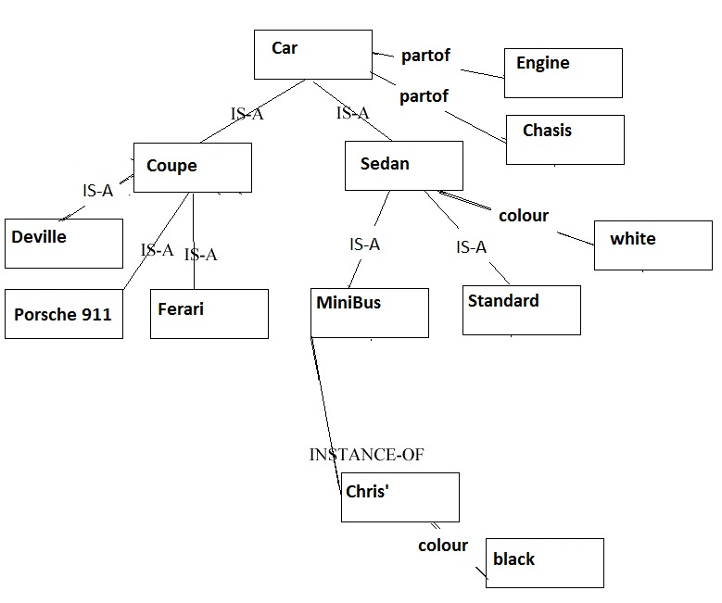

(d) What is the value of XML?
(5 marks) Marking scheme:
2 points reasonable answer.
2 points for solid answer.
1 points for excellent answer.
Sample answer:
One of the major values of XML is that enables a text document to be marked up with a restricted set of tags that can be easily searched by a machine. So a car ML might be used to mark up documents about cars, making it easy to find documents about specific types of cars. XML is also valuable for standardisation. If a lot of people are using the same ML (e.g. math-ML), it makes it easier to understand complex documents. Similarly, this standard can be used for interchanging data of a restricted format.

3. Machine Learning
(a) Case based reasoning often uses nearest neighbour to find the nearest case to a queried case. The cases are represented by four integers, and three cases are (10,5,2,7); (4,3,9,8); and (3,7,5,11). Using Euclidean distance, which is closest to the queried case (5,5,5,5)?
(5 marks) Marking scheme:
2 points rough calculation
3 points for correct
Sample answer:
Sqrt((10-5)^2+(5-5)^2+(2-5)^2+(7-5)^2) =
Sqrt(5^2+0^2+-3^2+2^2) =
Sqrt(25+9+4) sqrt(40)
Sqrt((4-5)^2+(3-5)^2+(9-5)^2+(8-5)^2) =
Sqrt(1^2+2^2+4^2+3^2) =
Sqrt(1+4+16+9) = sqrt(30)
Sqrt((3-5)^2+(7-5)^2+(5-5)^2+(11-5)^2) =
Sqrt(2^2+2^2+0^2+6^2) =
Sqrt(4+4+36) = sqrt(44)
(4,3,9,8) is closest.

(b) In this CBR system, there are only four possible outcomes. Instead of the Euclidean distance measure, would a self-organising map be a good retrieval metric. If so, describe how the system would work. If not, why not.
(8 marks) Marking scheme:
2 points for yes, though a reasonable no response is plausible.
4 points for breaking it into four SOMs
2 points for choosing from the node closest (or alternative).
Sample answer:
It could work reasonably well. The SOM units would cluster around the locations of the known cases. A good way to make this work is to have four SOMs one for each of the possible outcomes. Train these in the usual way. When you have a new case, see which of the SOM nodes is closest. The node that is closest would be a nearby case, so you could use that solution. You might also want to use a voting mechanism to see if several nodes in a particular SOM are close as opposed to just one in another.

(c) Would a genetic algorithm be a good retrieval metric? If so, describe the genes and the evaluation function. If not, why not?
(6 marks) Marking scheme:
2 points a description of why it might not work.
2 points for some description of how a gene and evaluation function might work.
2 points for a solid answer.
Sample answer:
If there was a lot of data, and the actual evaluation was relatively simple this approach might work. Otherwise, I can’t see any way that a genetic algorithm would work. You might be able to encode sample answers along with their category, but this would make for a long gene, which would take a very long time to train. So, in essence the gene would consist of several data points along with the categories associated with them. A gene might categorise something based on distance from the gene’s point to the new data point. You could evaluate on how well it categorises unseen data. Storing the points themselves seems a lot more effective. You might be able to “learn” the nearness metric; for instance you could weight the various features to make some more important than others. This could be part of the gene. Genetic algorithms are good when you don’t know anything about the domain, and this is when CBR systems are good. However, the match doesn’t seem right.

(d) In general, how can you determine if a retrieval metric is effective.
(6 marks) Marking scheme:
3 points for it works. It categorises correctly.
3 points for showing how you show it works.
An extra point or two for using experts (up to 5).
Sample answer:
A retrieval metric is effective if it works. You can test this with your case base, by in essence doing an n-fold test. Take your case base and break it into, say, four sets. Retrieve using three sets as the case base, and use the fourth as a test. How well does it categorise the outputs. You should then do it with the other 3 tests. If it works well, it is a good retrieval metric. You might also want to use new data and see if experts agree with the categorisation.

4. Applications
(a) Describe three widely used applications of computer vision.
(6 marks) Marking scheme:
2 points for each type of application.
Sample answer:
Computer vision has a wide range of applications, including optical character recognition, face recognition, robotic vision, and detection of abnormalities in x-ray images. Optical character recognition is used in handwriting detection. An image is processed and converted to a textual representation. It’s been used for some time in automatically directing post. Robotic vision is often used to help a robot sense its environment; this a hard problem in general, but in specific domains (e.g. industrial robots) it is quite effective. Vision systems are also used to read x-ray images. For example, they can detect tumors in these scans, sometimes better than expert radiologists.

(b) The Hopfield network is a connectionist system, as is a Multi-layer perceptron. The standard model of a Hopfield unit is roughly the same as MLP unit model with a step transfer function. These are both roughly the same as the integrate and fire neural model (McCullouch Pitts). Describe this model. For full points, use mathematical equations.

(10 marks) Marking scheme:
3 points for integrator
3 points for threshold
2 points for equations
2 points for correct equations.
Sample answer:
These are all integrators. They integrate the inputs modified by weights. For all i inputs x, and all i weights w, Sum(x^{i}*w^{i}) = k. k is the input to the step function, which also takes a threshold. If k>threshold the ouput is 1 (a spike) if not, it’s 0 (no spikes).

(c) Google has developed a self-driving, robotic, car. Describe sensors that this car might have. Describe the effectors it might have. Which of these effectors and sensors are you certain that it has; you can argue why you are certain or merely state how you know that it has these.
(9 marks) Marking scheme:
3 points effectors
3 points for sensors
3 points for reasonable statements of certainty.
Sample answer:
Without looking it up, the self-driving car has to have the same effectors that a normal car has. It turns, accelerates, breaks, and signals. It might also give extra output so that it can be debugged. It also has a bunch of sensors. It probably uses vision, but also makes use of sensors that people don’t have like radar, and lidar (which bounces light off objects). It has gps which is a sensor. I’m certain about all of these things but radar. I’ve read about lidar, and the initial effectors, gps, and vision seem obvious.
(The wiki mentions lidar, but not the others. Anyone care to look it up?)

