May 2017

Examination Paper Solutions

SOLUTIONS – NOT FOR STUDENTS

School of Science and Technology
MIDDLESEX UNIVERSITY
EXAMINATION PAPER
Academic Year 2016/2017 (May)
CSD3939

Developing Artificial Intelligence
Prof C. Huyck

Time allowed: 3 Hours
Total number of questions: 4 Questions
Instructions to candidates: Answer all questions. Each question carries 25 marks.

Materials provided: Equipment permitted: None
Total number of pages: 3
EXAM PAPER CAN BE REMOVED FROM THE EXAM ROOM
No books, paper or electronic devices are permitted to be brought into the examination room other than those specified above.

Candidates are warned that credit cannot be given for work that is illegible

1. State Spaces
(a) A particular system using genetic algorithms represents its solutions by a gene of digits (0-9) of length 10. How many different solutions are there?
(8 marks)
Marking scheme:
2 for a reasonably large number > 100
2 for between 10^4 and 10^20 or reasonable argument.
4 for correct
Sample answer:
Each gene has 10 digits, so there are 10^10 unique genes. That’s 10,000,000,000

(b) Assuming that each solution could be tested in a second on your computer, could you exhaustively search the space in this calendar year on your computer? Why or why not.
(7 marks)
Marking scheme:
2 for no
2 for numbers
3 for reasonable explanation
Sample answer:
That’s 10,000,000,000 seconds, which is roughly 200,000,000 minutes, or 4,000,000 hours, or 10,000 days. No, you can’t search it exhaustively in a year on your computer.

(c) If this system finds good results, what are the key properties of the state space that enable it to do so?
(10 marks)
Marking scheme:
2 similar genes should have similar values from the evaluation funciton.
4 regularity
4 for adjacent genes are particularly important.
Sample answer:
The key to finding a good solution is regularity. That is, genes that are close to each other (share adjacent digits) should have similar values. So, the value of 1234567890 should be near to 1234567899. It is important that the evaluation function is effective and that genes that are similar, should have similar values. It is useful for building block of good solutions can be built. So, if a good result starts with 123, it is useful that genes that start with 123, are better than those that start with other values.

2. Knowledge Representation
(a) Name six types of arcs in semantic nets. These should be the most important types of arcs.
(8 marks)
Marking scheme:
2 points isa
2 points instance
2 points (1 for each) of one of my other four.
2 points for other reasonable arcs (mine are not exhaustive)
Sample answer:
The most important arc is isa, followed by instance. Almost all semantic nets should have these. Other arcs are less important, but many systems use part-of and causes. Others include time, and location.

(b) Write a logical formula for the statement: If Chris is wearing white shoes, it is the summer.
(5 marks)
Marking scheme:
2 points if (you don’t have to use my sign)
3 points for correct
Sample answer:
w->s
w is chris is wearing white shoes
s I it is summer.

(c) Write a truth table for the statement above (part 2b).
(5 marks)
Marking scheme:
2 points for correct number of cells
3 points for correct table
Sample answer:
-> | w | -w
s | T | T
-s | F | T

(d) MathML(the mathematical markup language) was the first XML language recommended by W3C. It is used to describe mathematical formulas in documents. Why is it useful? (I don’t expect you to know much about MathML in particular.)
(7 marks)
Marking scheme:
3 points for semantics.
2 points for automated searching of documents.
2 points for style sheets or other reasonable answer.
Sample answer:
MathML is useful mostly because it attaches semantics to tags. This enables automatic searching of documents based on these semantics. It also allows people to find further information about tags. A secondary use is that notation can be changed by style sheets in case different communities are using different notation for the same mathematical symbols. (For example, one group may use 1,000,000 and another 1.000.000.)
3. Machine Learning
(a) There are two sets of two dimensional data (-1,3; -4, 5; -3, 7) and (1, 2; 5,9; 19,8). (The first point in the first set is (-1,3).) Plot the points and draw a line that separates these items.
(7 marks)
Marking scheme:
2 points for the points
1 point that shows they’re different
4 points for a line.
Sample answer:

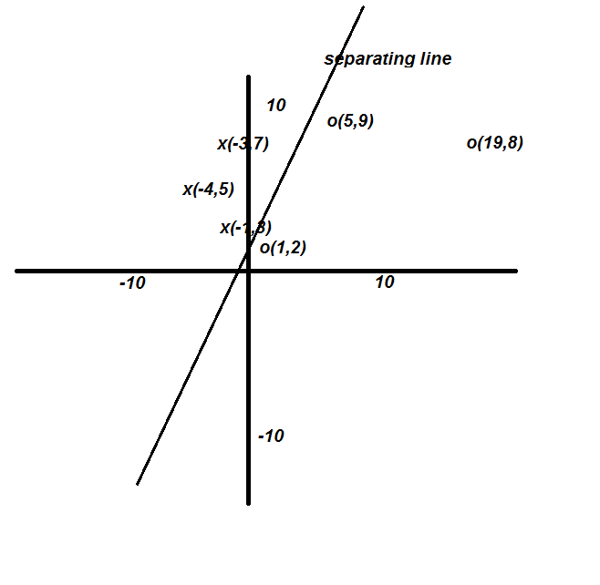
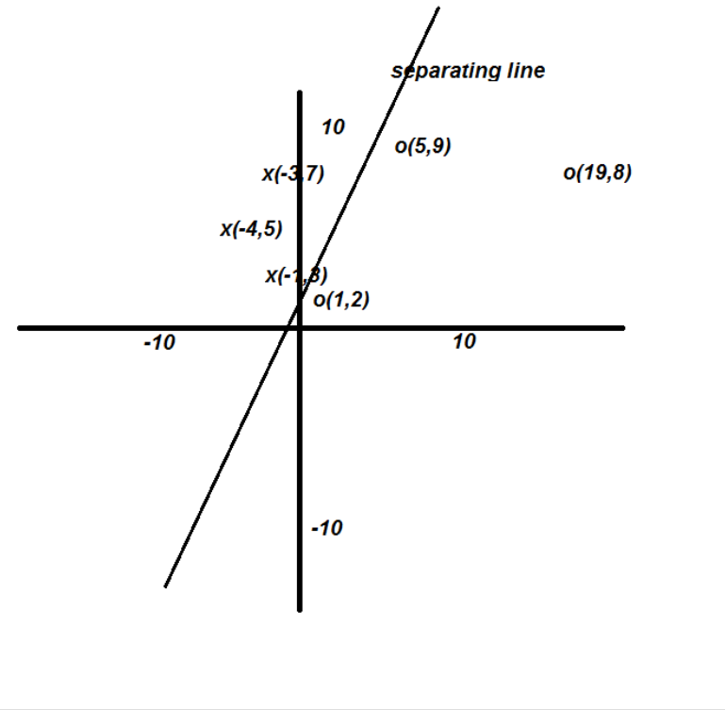
(b) How would a single perceptron separate two sets of two dimensional data?
(9 marks)
Marking scheme:
3 points linear separator.
3 points for step function
3 points for the weighted arcs, or other reasonable statement on the issue (planar works)
Sample answer:
A binary perceptron is a linear separator. That is, if the perceptron has a step true function, it will return true for inputs on one side of a line, and false for inputs on the other. So, for the data in part a, if the weights coming into the perceptron are set correctly, they will return true for one category, and false for another. If the inputs were 3D, the separator would be planar, and above 3D would be hyper-planer.

(c) Why are deep belief nets so successful at learning complex tasks (such as speech recognition) from large data sets?
(9 marks)
Marking scheme:
3 points large number of parameters.
3 points good learning algorithms
3 points lots of data
Sample answer:
Deep belief nets have a very large number of parameters to be set. These parameters are the weights between the nodes in different layers. If each layer has 100 nodes, and the layers are well connected, there are m*10,000 parameters where m is the number of layers – 1. Unlike backpropagation, modern learning algorithms allow these parameters to be effectively set. Backpropagation is only effective in the first two or three layers of a network. Finally, the existence of large data sets gives the system sufficient information to be used to learn to set these weights.

4. Applications
(a) One of the key problems in machine natural language processing is understanding the semantics, or meaning of words and sentences. Why is this so difficult for a machine?
(9 marks)
Marking scheme:
3 points semantics is learned from interaction with the world
3 points machines don’t interact with the world much, and not in varied ways
3 points we don’t currently know how to make machines learn this type of rich semantics
(Other reasonable answers will be given appropriate points.)
Sample answer:
The semantics of a word or sentence is its meaning. In GOFAI, this was represented by a symbol so *dog* represented the semantics of dog. While some processing can be done with this, there are a lot of semantics in dog. In this case you have to disambiguate the word, with the prime meaning being a house hold pet, but even assuming that, the semantics of dog include things about their size, their being mammals, their being man’s best friend, what they like to eat, what they do and so forth. This task becomes even more complex with sentences, as there is often a great deal of ambiguity in a sentence, and there is almost always a great deal of assumed information. Each person has spent a long time learning about the world, and thus has a very rich semantic representation. When a human processes a word or sentence they can bring this semantic knowledge to the task. Current AI technology is not capable of learning this rich semantics.

(b) A Tesla robotic car was involved in a fatal car accident in 2015. Describe how that car might have worked, and how it might have gone wrong.
(8 marks)
Marking scheme:
2 points sensors.
2 points effectors
2 points for other things like learning, maps, gps (though it is a sensor) and pictures.
2 points for reasonable guess at failure.
Sample answer:
The robot car has many sensors including lidar, gps and vision sensors. It has similar effectors to those humans have, a steering wheel, brake and accelerator. It has a great deal of knowledge about its particular environment from maps and perhaps pictures of where it is going. There is also a goal for the car to go to a certain place. The machine has also spent a great deal of time learning about the behaviour of itself and other cars. In this case, the car was driving in very bright light, and was unable to detect a truck. It was supposed to only be a driving assistant, but the human driver was not engaged and ran into the truck at high speed. The system failed because it was in a situation that was quite different from other situations it had encountered, and its sensors failed to detect the truck.

(c) The engineer who has been running the ancient heating system in the Town Hall is retiring after maintaining that system for 40 years. How would you determine if it might be useful to build an expert system to help the new engineer who is replacing him?
(8 marks)
Marking scheme:
4 points talk with the engineer (be a knowledge engineer)
2 points look at the larger economic status (talk the manager others)
2 points for issues about rules, cases or prototyping.
Sample answer:
A good way to determine if it might be useful is to discuss the heating system with the expert. He might have rules or cases that can be useful to explain the problem, and can readily be translated into an expert system. It might also be useful to discuss this with the engineer’s manager; if the heating system is going to be replaced, it’s probably not very useful to build an ES. Finally, it might be useful to talk to the replacement engineer, or others in the engineering team; if they know how to do it, or find it very difficult to do, this could influence the building of an ES. If it is promising, a prototype is a good way to start.

