July 2017

Examination Paper Solutions

SOLUTIONS – NOT FOR STUDENTS

School of Science and Technology
MIDDLESEX UNIVERSITY
EXAMINATION PAPER
Academic Year 2016/2017 (July)
CSD3939

Developing Artificial Intelligence
Prof C. Huyck

Time allowed: 3 Hours
Total number of questions: 4 Questions
Instructions to candidates: Answer all questions. Each question carries 25 marks.

Materials provided: Equipment permitted: None

Total number of pages: 3
EXAM PAPER CAN BE REMOVED FROM THE EXAM ROOM
No books, paper or electronic devices are permitted to be brought into the examination room other than those specified above.

Candidates are warned that credit cannot be given for work that is illegible

1. State Spaces
(a) The missionaries and cannibals problem involves three missionaries and three cannibals crossing a river. Only two people can be in the boat at the same time, and the cannibals can never outnumber the missionaries on either side of the river. About how many states are there in this problem? Give some of your reasoning.
(9 marks)
Marking scheme:
3 points for a solid start (e.g. 128)
3 points for fewer because of symmetry.
3 points for unreachable and illegal states.
Sample answer:
A simple analysis is that there are 7 entities, 3 cannibals, 3 missionaries and a boat. Either can be in 2 states, so at most 2^7 or 128. Many of these states are identical (e.g. it doesn’t matter which cannibal is on side 1), so there are probably many fewer (say around 32). Also, some may not be reachable, and many are illegal.

(b) Perform a breadth first search on this space looking two moves ahead.
(8 marks)
Marking scheme:
2 points represent start state
4 points first move
2 points second (note you can put the ignore states in I’ve removed)
Sample answer:
3c3mb| -> (c3m|2cb)(2c2m|cmb)(2c3m|cb) ->(2c3mb|c)(twice ignore second)(ignore start state)
Do note that I’ve not expanded illegal states.

(c) Could you perform a minimax search on this problem? Explain why or why not.
(8 marks)
Marking scheme:
2 points for no.
3 points for minimax is adversarial
3 points for reasonable complete answer.
Sample answer:
No, you really can’t perform a minimax search. Minimax is adversarial, and there is no adversary in this context. Moreover, it’s not really clear how to evaluate how well an intermediate state is doing. The results are only done or prune. Consequently, a depth or breadth first search is the way to go.

2. Knowledge Representation
(a) Draw a Semantic Net for automobiles. Include 12 nodes, and at least five types of arcs. Include the most important types of arcs.
(11 marks)
Marking scheme:
2 points for isa
2 points for instance
2 points for other 3 types
3 points for 12 nodes
2 points for good overall net
Sample answer:

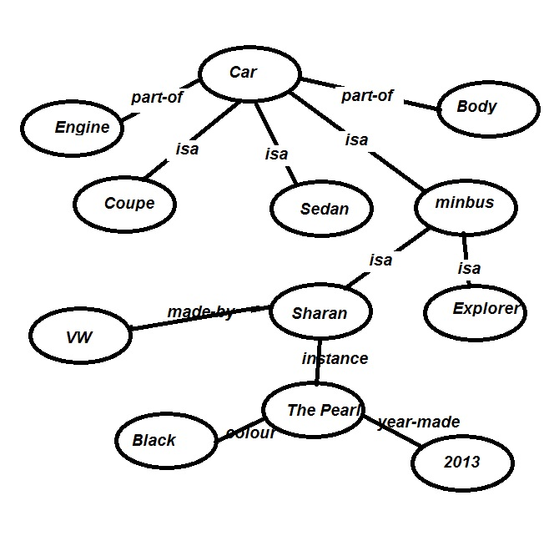
(b) Write a series of rules that describes the behaviour of British traffic lights (red, red and amber, green, amber, red…).
(7 marks)
Marking scheme:
2 points reasonable rule format
2 points for reasonable rules
3 points for correct answer (-1 for three state traffic light) (note I’m not particularly concerned about the rule notation below. Clips or another reasonable system would work.
Sample answer:
If (state(red)) => state(red and amber)
If (state(red and amber)) => state(green)
If (state(green)) => state(amber)
If (state(amber)) => state(red)

(c) When is it wise to develop a new XML language? Provide an example.
(7 marks)
Marking scheme:
2 points lots are going to use it.
2 points for machine and human processing of documents written in the language.
3 point overall good answer; mine is not exhaustive.
Sample answer:
Aside from learning how to build xml languages, the only time it is reasonable to build a language is when a lot of people are going to use it (or you hope that a lot of people are going to use it). Also, there should not be an existing language that already addresses the domain. It’s useful if the domain is relatively large, but not too large (say between 100 and 1000 tags). Finally, it’s better if both people and machines are going to use the documents. Assuming that there is no such language an XML for books might be useful. A lot of people talk about, and trade in books. There are a lot of documents about books. This could make it useful for people communicating about books, and for using the documents for both human and automated processing.
3. Machine Learning
(a) A self organising map (SOM) uses a distance measurement to find the distance between two data points. Find the Euclidean distance between the 3D points (5,4,7) and (-5,10,3).
(4 marks)
Marking scheme:
2 points for formula
2 point for something close to right answer (12 or 13 works, 1 point for sqrt(152))
Sample answer:
Sqrt((5- -5)^2+(4-10)^2+(7-3)^2) =
Sqrt(100 + 36+16) =
Sqrt(152) ~ 12.5

(b) How does a SOM represent the data it is trained on?
(8 marks)
Marking scheme:
4 points a series of points.
4 points for a node represents many input data points
Sample answer:
The input data is represented by a series of points. The learning algorithm moves the SOM nodes toward these points, so these too are represented by a series of points. Typically there are many more data points than there are SOM nodes, so each node will represent many points. If a particular area has a lot of data points, it should have a lot of SOM nodes.

(c) What is the Mexican hat function, and how is it used in SOMs?
(7 marks)
Marking scheme:
2 points for nearest node moves most toward data item
2 points for other nearby nodes move toward
2 points for further nodes move away
1 point for furthest nodes don‘t move.
Sample answer:
The Mexican hat function affects the way nodes move during training. For a given data point, the nearest node moves toward the point. Nearby nodes also move but not by as much. Those slightly further away move away from the data point, and those furthest away are unaffected. The hat (like a sombrero or Mexican hat) is highest for the nearest, decreases for those nearby, becomes negative slightly further away, and then becomes zero for the brim, those furthest away.

(d) A support vector machine often makes use of a kernel function. What is the kernel function used for?
(6 marks)
Marking scheme:
3 points for linear separability.
3 points for projecting the data into a higher dimension.
Note kernel functions can be used for a variety of puposes, and reasonable answers will be granted points.
Sample answer:
A support vector machine works by building vectors that separate different parts of the data. If the data is not linearly separable, this will not work very well. If this is the case, a kernel function is used to translate the data into a higher dimension where the data is linearly separable. A good example of this is data that is with a certain radius of a point being in the category, and data further away not being in the category. No line separates this data, but a circular kernel function can project this 2D data into 3D where a plane separates the category.

4. Applications
(a) Many computer vision problems rely on static pictures. How are these pictures typically represented?
(8 marks)
Marking scheme:
2 points for something reasonable (e.g. lines, but of course pixels)
3 points for pixels
3 points for grids and number of bits
Sample answer:
This is really quite simple. Pictures are typically represented by a grid of pixels or picture elements. These pixels can be binary (black and white), or a higher number of bits including gray scale and colour. There are other mechanisms for representing pictures (e.g. series of lines), but these are atypical.

(b) Perhaps the largest AI application is Big Data, and the set of current algorithms with the most interest for addressing large data problems is types of Deep Nets. Are Deep Nets the best solution to all machine learning problems? Why or why not.
(9 marks)
Marking scheme:
3 points for no
3 points for no free lunch theorem.
3 points for overall solid answer (which you can get independently of the first two sets of points)
Sample answer:
No, deep nets are not the best solution to all machine learning problems. The No Free Lunch theorem guarantees that it actually does worse than just guessing on the average problem. None the less, they are effective in many circumstances where there is a great deal of data, and there are many latent variables.

(c) Cognitive models are ways of representing human behaviour. How would someone develop a cognitive model of multiplication?
(8 marks)
Marking scheme:
2 points model works like people do.
2 points for fails when people do
2 points for takes longer with some tasks than others
2 points for levels and learning
Sample answer:
The model would have to behave the way people did. A good mechanism would be to learn to multiply the way people learn. Typically they first multiply small pairs like 2x3, just by extending addition. Eventually, they learn to cash away the 10s time tables (e.g. 7x8 = 56). They still need a process to multiply larger numbers (like 23x34). Crucially, people take longer on some types of problem than others, and fail. A good cognitive model would consider this.

