School of Science and Technology
MIDDLESEX UNIVERSITY
EXAMINATION PAPER Solutions
Academic Year 2015/2016 (July)
CSD3939

Developing Artificial Intelligence
Prof C. Huyck

Time allowed: 3 Hours
Total number of questions: 4 Questions
Instructions to candidates: Answer all questions. Each question carries 25 marks.

Materials provided: Equipment permitted: None

Total number of pages: 3
EXAM PAPER CAN BE REMOVED FROM THE EXAM ROOM
No books, paper or electronic devices are permitted to be brought into the examination room other than those specified above.

Candidates are warned that credit cannot be given for work that is illegible

1. State Spaces
(a) What is the size of the search space for chess? Explain your reasoning.
(8 marks)
Marking scheme:
2 points for vast
2 points for a reasonable number.
4 points for explanation.
Sample answer:
The space is vast. There are 32 pieces. To start let’s just assume they’re all different. There are 64 squares. Pieces can eventually end up in almost any square, so the size of the space is going to be something like 64*63*62*…34*33. Let’s just make those all 50s so it’s around 50^32 which equally 5^32*10^32. The number of atoms in the universe is around 10^23.

(b) What is a commonly used search algorithm for playing chess? Describe it briefly.
(9 marks)
Marking scheme:
2 points for the name.
2 points evaluation function
2 points look ahead
3 points alternating minimum and maximum passing up.
Sample answer:
The commonly used search algorithm for chess and other adversarial games is mini-max. From the current state look forward over all possible moves. In the case of chess you can’t look very far forward. You apply an evaluation function to states you’ve looked at. You pass up the values from further states forward. If it is one player’s (say white) move, you pass up the maximum of the next states. If it is the other’s you pass up the minimum. If the agent is playing white, he picks the maximum move. These can be extended with alpha-beta pruning and iterative deepening.

(c) Chess playing algorithms need an evaluation function. What might be some of the properties of a chess evaluation function?
(8 marks)
Marking scheme: I don’t expect people to know the answers, but to come up with reasonable things.
2 points for winning and loosing
2 points for positive values for white, negative for black
2 points for pieces
2 points for other reasonable answers. Include responses from 1b.
Sample answer:
Firstly, the system should return the largest value for winning, and the smallest value for loosing. Beyond that the common answer is points. The more pieces and the more powerful the piece, the larger your result; similarly, the more the opponent has the worse your result. Other things that are important are threatening the king and queen, control of the centre, pawn advancement, and pawns becoming queens (when they get to the 8th rank).
2. Knowledge Representation
(a) Draw a Semantic Net to describe Mammals. Include at least 12 nodes and 4 types of arcs. Include the most important type of arcs.
(11 marks) Marking scheme:
4 points for 12 nodes
2 points for isa
2 points for instance
3 points other arcs
Sample answer:
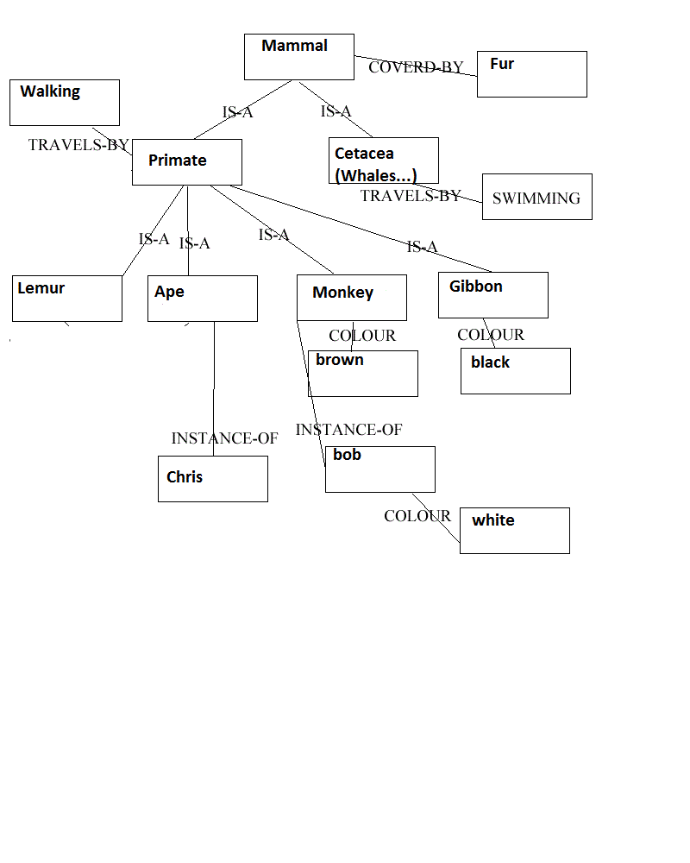

(b) Write a logic formula for: all students want to pass the exam.
(4 marks)
Marking scheme:
2 points for function
2 points all, forall ok too.
Sample answer:
All(x): pass(x,Exam)

(c) Write a logic formula for: there is a student who studies hard but does not get a first on the exam.
(4 marks)
Marking scheme:
1 point each for function, and , not, exists
Sample answer:
Exists(x): studiesHard(x) and –getFirst(x,Exam)

(d) Why is it useful to represent knowledge in some format such as logic or a semantic net? What are these two formats particularly useful for?
(6 marks)
Marking scheme:
2 points for they help the system reason
2 points logic and deriving new facts
2 points semantic nets
Sample answer:
If a system needs to reason about something, it is helpful to a have the knowledge of that something encoded in a standard format. That format can make it easier to reason about certain aspects of that knowledge. If the format is a logical format, then the system can reason about facts and derive new facts from the knowledge it already has. If the format is a semantic net the system can derive facts via inheritance, and can reason about relationships between different pieces of knowledge.
3. Machine Learning
(a) How would you divide a data set of 1000 items for a 5-fold test?
(4 marks)
Marking scheme:
3 points for having 200
1 point relatively equal.
The rest of the answer isn’t necessary for points.
Sample answer:
Firstly, you break it up into 5 sets of 200. You might want to assure that they are relatively equal; for instance if it’s a categorisation task, you might want each set to have a roughly equal number of each category. You would either train on one set and test on the other 4 combined, or train on 4 sets and test on the 5th. You would then switch through each set, so you would run the system 5 times.

(b) The travelling salesman problem involves finding the shortest path through a set of n cities. If you wanted to use a genetic algorithm to solve the travelling salesman problem, what would be the evaluation function?
(4 marks)
Marking scheme:
3 points for returning the length
1 point for the input
Sample answer:
The evaluation function would take a gene that described a path and return the length of the path.
(c) For the same travelling salesman problem, what would a gene represent, and how would it represent that?
(10 marks)
Marking scheme:
4 points for a reasonable representation
3 points a complete representation (like the 50x50 cities below)
3 points for issues (like repetition) or better solution.
Sample answer:
There are a lot of ways to represent a path with a gene. Perhaps the simplest is to just have each element of the gene represent a city. So if there were 50 cities, then each element would be a number between 1 and 50, and there would be 50 numbers. The problem with this is that most of the genes would be invalid because they would have at least one city multiple times. A cleverer mechanism would leave more valid genes. So, you could have the numbers represent the next city in the remaining list. For example, if there were 5 cities the first would represent the first city say 1, the second would be the next 3, and the third 2. The city remaining tuple would look like ((1);(2,3,4,5))((1,4);(2,3,5))((1,4,3);(2,5)). The next choice would be 1 (2) or 2 (5), and the final choice would be 1. When new genes were created, some early bits could be invalid, say (1,4,4), but many fewer than the city description.

(d) What are the support vectors in a support vector machine?
(7 marks)
Marking scheme:
2 points for it’s a line or a vector.
2 points for it separates the two classes
3 points for completely correct.
David notes ) NOTE: commonest soft margin SVM doesn't need linear separability

- most accurate to say that support vectors collectively define max margin hyperplane.

Sample answer:
For SVMs to work, you need a linear separable data set. (You use the kernel trick if the data is not linearly separable.) If you’ve got a multiclass problem, you can translate it to a two class problem, so for this description, assume a two class problem. A support vector is a line (plane or hyperplane depending on the dimensionality) that is on the edge of a class, separating it from the other class. So, there are two support vectors, one on the edge of each of the two classes.

4. Applications
(a) Robots are often used in automobile factories. What are some of the sensors and effectors that these robots use?
(7 marks)
Marking scheme:
3 points for effectors
3 points for sensors
1 point for a complete answer (which the marker can think of as an extra one for sensors, effectors, or well explained).
Sample answer:
There are of course a lot of different robots in automobile factories. If the robot is for welding, its effectors include a torch or electrical circuit for doing the weld. If it’s for painting, its effectors include a spray paint nozzle. It’s often also going to have hold the part its working on, so it will have grippers (hands). The sensors will probably have some vision component to assure things are aligned appropriately. It may also have weight and touch sensors for the hands. I’m pretty sure that some robots use x-rays to assure that welds are correct. Robots aren’t limited to the human senses so might use lidar, or radar too.

(b) Describe three components of a typical automatic summarisation system.
(9 marks)
Marking scheme:
3 points for each component
A description of any 3 of these components will do. Something like the first 2 sentences below is useful but unnecessary.
Sample answer:
The standard NLP system cascade is lexicon, syntax, semantics, dialogue. An automatic summarisation system will also probably have a similar reverse cascade for production and a component in the middle to reduce the size of the dialogue tree. I’ll describe lexicon, syntax and pruning the dialogue tree.
- The lexicon takes the words, stems them and gives part of speech. This may also include gazateer components for proper names, but this can be considered a simple system. The lexical analyser is typically a regular grammar system (like the Brill tagger) that can be trained from a corpora.
- Parsing (or syntactic analysis) takes the output of lexical analyses (parts of speech) and builds a parse tree that represents the syntax of a sentence. It works on a sentence by system basis. The syntax tree could also support semantics of the sentence, though this is usually a separate step.
- This is not a complete description of semantic analysis, but it typically yields a case frame that represents the meaning of the system. Default knowledge (not included in the sentence) may be present.
- This is not a complete description of dialogue analysis. A dialogue analyser typically takes sentences (case frames) as inputs and creates a dialogue tree where different sentences depend on others. So, the highest bits of the tree are most important.
- To summarise, all you need to do is pick the top of the tree. If you want a longer summary, you pick further down the top.

(c) Mario-Kart is a common video game with users competing against agents in a simulated car race. How would you build a Mario-Kart (or similar car game) agent?
(9 marks)
Marking scheme:
3 points for having an agent
3 points for good answer (fsa is good but others work too).
3 points for really good answer. (fsa is really good but others work too).
Sample answer:
Mario-Kart agents are pretty simple. They take input in the form of the map the current state of the game and generate outputs in the form of turning, accelerating or braking, and throwing things. An additional set of static inputs may come at the start of a particular race. A simple way to do this is with a finite state automata. The agent is in a current state, and can move to another state. It chooses, depending on the current state and the environment. There are other reasonable ways including just building functions that kind of work. One of the key issues for developing this function is that it is fast as it has to run in real time.

