School of Computing Science


May or August 2005
Trent Park Campus
2004/2005 Semester 2

Examination Paper Solutions

SOLUTIONS – NOT FOR STUDENT EYES

Solutions for Module Number: BIS 2040

Module Title: Knowledge Based Systems

Module Tutor’s Name: Christian Huyck

Time allowed: 2 hours

Total number of questions: 5

Example Solution Format

ATTEMPT ANY THREE QUESTIONS

Each question carries 25 marks

Question 1

- Here is a sentence: “If Pat and Terry both want the ball, Terry will get it.” Write a logic formula and truth table for this sentence.
Logic formula 4 marks
8 cell table 3 marks
Correct table 3 marks
[10 marks]

answer:
(P&T) -> G
P is Pat wants the ball, T is Terry wants the ball and G is Terry gets the ball.
PT P-T -PT -P-T
G T T T T
-G F T T T

- Conflict resolution must usually be done for rule-based systems. Describe what conflict resolution is, and describe two conflict resolution strategies.
Conflict Resolution description 3 marks
First strategy 3 marks
Second strategy 3 marks
[9 marks]

answer: conflict resolution is used during the recognise phase of the recognise-act cycle in a rule based system. During recognition, more than one rule may have its if-part true. Each rule that has its if part true is put into the conflict set. Conflict resolution is used to decide which of the rules in the conflict set to apply. One strategy is specificity which applies the rule that has the most clauses in the if portion.. A second strategy is order, where the rule that is defined first is selected.

- Rule-based systems are similar to logic, but rule-based systems do no always give the correct logical answer. Define a rule set and initial facts that give the correct logical answer when one of your conflict resolution strategies is used and an incorrect answer when the other conflict resolution strategy is used.

Rules 2 marks
Contradictory 4 marks
[6 marks]

Answer:
Strategy 1 is specificity.
Strategy 2 is order of definition.
The rules are
If (not (tall John)) then (assert (short John))
If (and(basketball player ?x) (age ?x 20)) => (assert (tall ?x))
If (short ?x) => (assert (not tall ?x))

The facts are (basketball player John) (age John 20)

Specificity makes the second rule fire because it has two clauses adding (tall John) to the facts. No other rules then fire.
Order makes the first rule fire adding (short John); the second rule then fires adding (tall John); the third rule then fires adding (not tall John). John is both tall and not tall which is contradictory.

Question 2

- A system for children’s toy selection is to be built. The final goal of the system is for the user to put in some details about the child, toys that the child already likes, and cost. The system will select a toy that the child will like. The first part of the system categorises children into one of several groups. You should build a decision tree for grouping the children. The first choice is based on age and there are 6 groups (0-3 months, 3-6 months, 6-12 months, 1-2 years, 2-3 years, and 3-5 years). For the children between 0 and 12 months, that is all that is needed. The older children are also categorised by their gender.

Question on root 2 marks
All 6 branches on age 3 marks
Gender on older only 3 marks
Reasonable leaves 2 marks
[10 marks]

answer: 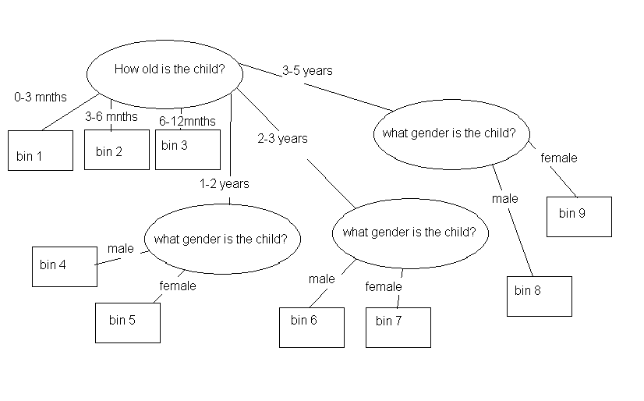

- For each group (from part a) a case-based reasoning system will be built. What features are important? What is an appropriate similarity metric? Give 3 sample toys. Show which of the second or third toys is closer to the first based on your metric.
Colour, size, cost, and other good features 5 marks
The distance measurement should be reasonable 2 marks
Similarity calculation 3 marks
[10 marks]

answer: it’s based on toys that children have liked before. So, reasonable features are needed for toys that children will like again. Here are a few I can think of and these can go across age and gender divisions: colour, size, type (car, soft, musical instrument, etc.), character associated with (e.g. Noddy, Barney, or no one), electronic and cost. Of course other features are relevant,.
Toy 1 Toy Car, red, small, car, none, manual, 2£
Toy 2 Ball, white, medium, sport, none, manual, 5£
Toy 3 bear, brown, small, soft, noddy, electronic, 5£

The distance metric needs a way of calculating distance between enumerated values. Lets use 8 colours (white, yellow, orange, red, brown, green, blue, purple and black), 3 sizes, type has 5 values (soft, music, other, car, sport), 3 values for character (both or neither have same character = 0, both have a character=1, one has a character and the other doesn’t 2), 2 values for electronic and cost is standard so
1-2 = sqrt(4 + 1 +1 + 0 + 0 +3*3) = sqrt(15)
1-3 = sqrt(1+ 0 + 3 + 2 + 1 + 3*3) = sqrt(16)
the ball is closer

- Once the system has chosen a toy, the user may reject it because, for example, the child already has that toy. What can be done in this situation?
Next closest 3 marks
Improving system with this 2 marks
[5 marks]
answer: The simplest thing is to just find the next closest thing. This can also be used as an opportunity to improve the system. If the reason is because the child already has the toy, the user could be asked if they like it, which would be evidence that the system is good, or if they don’t which is evidence that they don’t like it.
Question 3

- Here are 3 sentences involving transfer of possession:
Chris gave the ball to Sandy.
Sandy lost the ball.
Pat gave to Sandy.
Describe the facts (e.g. WM items) that represent these sentences.
Write three rules that represent these sentences. They should only run when the appropriate conditions are met (e.g. for the first sentence Chris must have the ball), and should add the appropriate new facts.

Facts 4 marks
Each rule 2 marks for a total of 6 marks
(note simpler version of pat gave sandy will acceptable)
(note retracts are not needed)
prereqs 2 marks
[12 marks]

answer: facts: (give Chris Sandy ball),(lose Sandy ball) (give Pat Sandy)
rules if ?f1 <- (has ?Actor ?Poss) (give ?Actor ?Recipient ?Poss) =>
(assert (has ?Recipient ?Poss)
(retract ?f1)
if ?f1 <- (has ?Actor ?Poss) (lose ?Actor ?Poss) => (retract ?f1)
you could also (assert (nolongerhas ?Actor ?Poss)
if (hasmoney ?Giver) (give ?Giver ?Recipient) => (assert (hasmoney ?Recipient))

- Write 4 frames that can be used for processing sentences about transfer of possession. 3 frames are the instances of the above sentence, and the fourth is the frame that they are derived from.
3 slots 3 marks
default 2 marks
inheritance 3 marks
[8 marks]

answer: Transfer Frame
Giver: person
Recipient : person
Item:

giveFrame isa TransferFrame
Giver: Chris
Recipient : Sandy
Item: ball

lost isa TransferFrame
Giver: Sandy
Item: money

giveFrame isa TransferFrame
Giver: Pat
Recipient : Sandy
Item: default money

- Write a rule that implements money as the default thing that is transferred.
Prereq) 2 marks
Correct 3 marks
[5 marks]

answer
if (hasmoney ?actor) (transfer ?actor ?recipient) => (assert (hasmoney ?recipient))
(as in part a)
Question 4

- Draw a Semantic Net for bicycles. Include at least 8 nodes, and the most appropriate relations.

8 nodes 3 marks
inheritance 2 marks
Part-of 3 marks
Reasonable 2 marks
[10 marks]

answer: 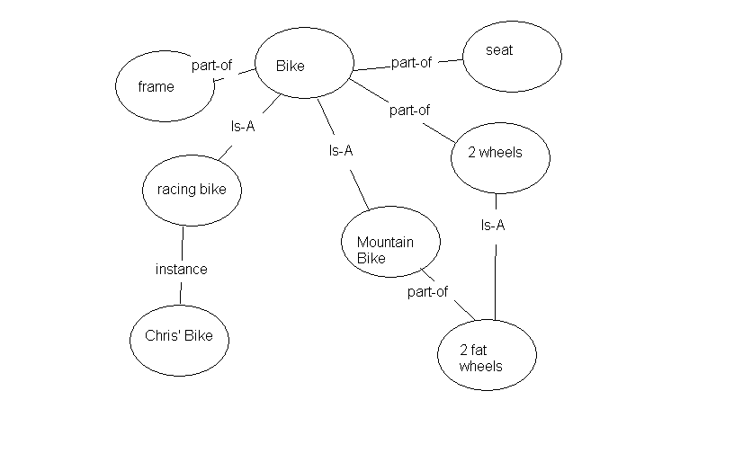

- If you wanted to have the best possible semantic network to help you repair bicycles, who would you ask? How would you go about asking them? What type of questions would you ask?

Who/experts 3 marks
How interviews 3 marks
Problem solving 3 marks
Prototyping 3 marks
Range of questions from simple to complex 3 marks.
[15 marks]
answer: The best person to ask would be an expert in bicycle repair. You could even ask multiple experts. Interviews would be a good way of asking the expert, but you could do even better by showing them prototype semantic nets. Furthermore, you could have them use the nets to fix bicycles and explain what they are doing. So, the type of question would range from initial questions about important parts, relations and example bicycles, to later questions about the quality of the existing net, how it could be used to solve a problem, and whether there are problems with it.

Question 5
Here is some text I took from http://www.library.cornell.edu/olinuris/ref/research/skill26.htm. It is the first part of a document entitled Critically Analyzing Information Sources

INTRODUCTION
You can begin evaluating a physical information source (a book or an article for instance) even before you have the physical item in hand. Appraise a source by first examining the bibliographic citation. The bibliographic citation is the written description of a book, journal article, essay, or some other published material that appears in a catalog or index. Bibliographic citations characteristically have three main components: author, title, and publication information. These components can help you determine the usefulness of this source for your paper. (In the same way, you can appraise a Web site by examining the home page carefully.)

I. INITIAL APPRAISAL
A. Author
- What are the author's credentials--institutional affiliation (where he or she works), educational background, past writings, or experience? Is the book or article written on a topic in the author's area of expertise? You can use the various Who's Who publications for the U.S. and other countries and for specific subjects and the biographical information located in the publication itself to help determine the author's affiliation and credentials.
- Has your instructor mentioned this author? Have you seen the author's name cited in other sources or bibliographies? Respected authors are cited frequently by other scholars. For this reason, always note those names that appear in many different sources.
- Is the author associated with a reputable institution or organization? What are the basic values or goals of the organization or institution?
B. Date of Publication
- When was the source published? This date is often located on the face of the title page below the name of the publisher. If it is not there, look for the copyright date on the reverse of the title page. On Web pages, the date of the last revision is usually at the bottom of the home page, sometimes every page.
- Is the source current or out-of-date for your topic? Topic areas of continuing and rapid development, such as the sciences, demand more current information. On the other hand, topics in the humanities often require material that was written many years ago. At the other extreme, some news sources on the Web now note the hour and minute that articles are posted on their site.
C. Edition or Revision
Is this a first edition of this publication or not? Further editions indicate a source has been revised and updated to reflect changes in knowledge, include omissions, and harmonize with its intended reader's needs. Also, many printings or editions may indicate that the work has become a standard source in the area and is reliable. If you are using a Web source, do the pages indicate revision dates?
D. Publisher
Note the publisher. If the source is published by a university press, it is likely to be scholarly. Although the fact that the publisher is reputable does not necessarily guarantee quality, it does show that the publisher may have high regard for the source being published.
E. Title of Journal
Is this a scholarly or a popular journal? This distinction is important because it indicates different levels of complexity in conveying ideas. If you need help in determining the type of journal, see Distinguishing Scholarly from Non-Scholarly Periodicals. Or you may wish to check your journal title in the latest edition of Katz's Magazines for Libraries (Uris Ref and Olin Ref Z 6941 .K21) for a brief evaluative description.

- If you want to build a system that does this automatically, you must determine the important features of an information source. According to the text, what are the important features? Give at least 10 features.

The author, date, edition, publisher, title of journal 5 marks
Other reasonable ones from the text including, authors organisation, background, and citations, how you heard about him, number of editions 5 marks
[10 marks]
answer: The obvious important features are the subsection titles: the author, date, edition, publisher, and title of journal. There a range of other features though most are concentrated in the author section. Five that I picked out were, authors organisation, background, and citations, how you heard about him, and number of editions.

- What is the best type of system for automatically determining a good source a rule-based system or a case-based system? Why? What would be the problems with the type of system you selected?

Note that either approach can work
Committing to an answer 1 mark
theory or none 3 marks
Size of problem 4 marks
[8 marks]
answer: I think the best type of system would be a rule-based system. This seems to be stating or at least beginning a theory and that implies a rule-based approach.

There would be problems implementing an ES (either rule or case based) because the domain is very large. There are certainly millions of sources, and different people have different needs.

- Write three useful rules that can help determine the quality of a source, and show the text that validates these rules.

Rules 3 marks
Reference to text 3 marks
Good rules 1 marks
[7 marks]

answer : Respected authors are cited frequently by other scholars
if (ref ?ref ?author) (citations ?author ?x) (test (> ?x 50)) => (assert (quality ?ref high))
Is the author associated with a reputable institution or organization
If (ref ?ref ?author) (location ?author ?place) (quality ?place ?high) => (assert (quality ?ref add))
Also, many printings or editions may indicate that the work has become a standard source in the area and is reliable
If (ref ?ref ?author ?edition) (test (> ?edition 5)) => (assert (quality ?ref add))

