School of Computing Science


May 2004
Tottenham
2002/2003 Semester 2

Examination Paper Solutions

SOLUTIONS – NOT FOR STUDENT EYES

SOLUTIONS – NOT FOR STUDENT EYES

Solutions for Module Number: BIS 2040

Module Title: Knowledge Based Systems

Module Tutor’s Name: Christian Huyck

Examiner: Christian Huyck

Time allowed: 2 hours

Total number of questions: 5 Questions Answer 3.

Example Solution Format

ATTEMPT ANY THREE QUESTIONS

Each question carries 25 marks

Question 1

- Here is a list of numbers: (72, 45, 62, 59)
Write facts that represent these numbers and their order in the list
Facts 3 marks
Order 2 marks
[5 marks]
answer: (num 1 72) (num 2 45) (num 3 62) (num 4 59)
There are four facts all represented by three-ary predicates. The first entry of the predicate is num to show that it is a list, the second shows the place in the list, and the third entry shows the value of the element.

- Write a rule that sorts the first two numbers in the list into ascending order (so that the first is less than the second). This should be a rule that will work for the first two numbers in any list.
Specific rule 3 marks
A general rule 4 marks
[7 marks]

answer: if ?f1 <- (num 1 ?x) ?f2<- (num 2 ?y) (test (< ?x ?y)) => (retract ?f1) (retract ?f2) (assert (num 1 ?y)) (assert (num 2 ?x))

- Write rules to sort any list of 4 items.
Specific rules 3 marks
General rules 4 marks
[7 marks]

answer: see d
- Write one rule that will sort any list in ascending order. (This can be an answer to parts b and c.)
One rule to get all 4 3 marks
One rule to get any length list 3 marks
[6 marks]
answer: answer: if ?f1 <- (num ?p1 ?x) ?f2<- (num ?p2 ?y) (test (< ?p1 ?p2))(test (< ?x ?y)) => (retract ?f1) (retract ?f2) (assert (num ?p1 ?y)) (assert (num ?p2 ?x))
Question 2

- At Chris’s Baby Clothes Shoppe, all of the clothes have a cost, a fabric they are made of, a colour, and size. The hats have a season that they are associated with. The t-shirts are either long or short sleeved, and all of the socks have a pattern.
Draw a series of frames to represent the clothes, and include at least three examples of specific clothes (tokens) as opposed to types of clothes (types).

Basic frame 4 marks
Frames for hat, shirts and socks 3 marks
ISA and instance 2 marks
Instances 3 marks

[12 marks]
answer:

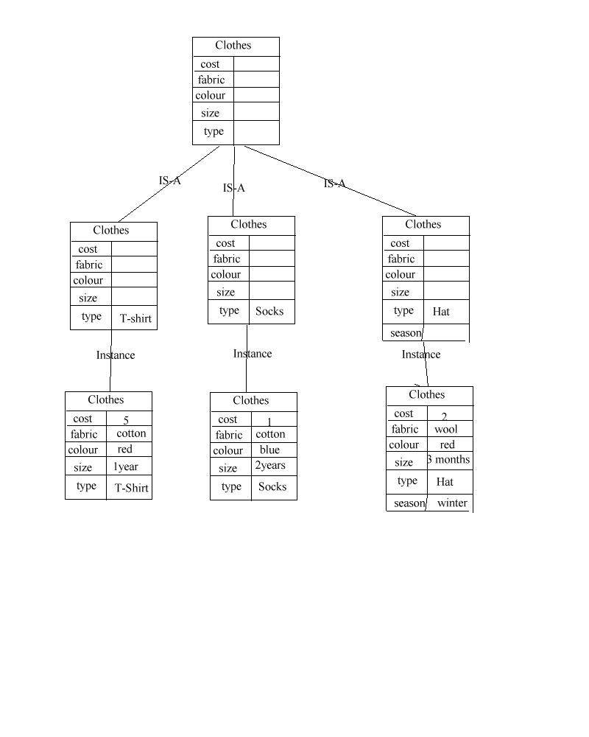

- At the store, all hats cost 2 pounds. Show the frames that need to be modified to show this fact.

Correct change of the hat frame 3 marks
Modification of only the hat frame, and its instances 3 marks

[6 marks]

answer: change the hat frame to have cost 2. In this case, the instance of the hat frame does not need to change.

- Write the hat frame from part a as a fact. Write a rule that translates that fact into a new fact according to the rule of part b.
Fact 1 3 marks
Rule 4 marks

[7 marks]
answer: (hat ?cost ?fabric ?colour ?size ?type ?season)
?f1 <- (hat ?cost ?fabric ?colour ?size ?type ?season) -> (retract ?f1) (assert (hat 2 ?fabric ?colour ?size ?type ?season))
Question 3

- Write a logical expression that describes the following sentence:
If a seed gets enough water, enough sun, and is planted in the spring, then it will probably grow.
State what your variables mean.

Correct and 2 marks
Correct second and 2 marks
Correct if 3 marks
Correct variable assignment 3 marks
[10 marks]

answer : W is seed gets enough water; S is seed gets enough sun; P is seed is planted in spring; G is seed will probably grow
W & S & P -> G
- Build the truth table for the expression.

Correct table with 2 variables 2 marks
Correct table with 4 variables 4 marks
Correct answer 4 marks
[10 marks]

answer:
 | WSP | WS-P | W-SP | W-S-P | -WSP | -WS-P | -W-SP | -W-S-P
G | T | T | T | T | T | T | T | T
-G | F | T | T | T | T | T | T | T

- What would be the best type of system (rule based, case based or other) to assure that statements are valid? Why?

Rule-based 2 marks
Reason (including a good reason why the other) 3 marks
[5 marks]
answer: A rule based system is best because you want to follow logical rules. Logical rules are easily accounted for by Rule Based Systems using facts with boolean values.
Question 4

- Draw a semantic net that would be used by an automobile dealer. It should have at least 8 nodes and 4 types of arcs.

Nodes 3 marks
Inheritance relation 3 marks
Other arcs 2 marks
Reasonable Net 2 marks

[10 marks]
- If you were going to develop an expert system for helping people select cars to purchase, and this system were to use a semantic net, then how would you improve your semantic net.

Discuss with an expert 3 marks
Test in a prototype 3 marks
Discuss with a (potential) user 2 marks

[8 marks]
- What type of Expert System would you use (rule based, case based or other) and why?

It depends on how an expert does it 3 marks
Reasonable answer 2 marks
Probably other because it’s very complex 2 marks

[7 marks]
Question 5

- A case based expert system has been designed to select the correct shrub for a garden. The system starts with four cases. The first case is a 5x10 meter garden, with 3 other shrubs; the correct shrub to add to this is a Japanese Maple. The second case is a 10x10 meter garden with no other shrubs; the correct shrub to add is a Lilac. The third case is a 9x9 meter garden with 5 other shrubs; the correct shrub to add is a rose bush. The fourth case is a 5x5 meter garden with 2 other shrubs; and you should not add another shrub.
How do you represent the cases?
2 distance features 3 marks
1 shrub feature 2 marks
1 output feature 2 marks
[7 marks]
answer:
5 10 3 JM
10 10 0 L
9 9 5 R
5 5 2 N
- Using a straight-forward distance metric, calculate which shrub to use for a garden that is 7x7 and has no shrubs. Give your distances.
Distance for maple 2 marks
Distance for rose 2 marks
Distance for other two 2 marks
Correct answer 2 marks
[8 marks]
answer:
sqrt((7-5)^2 + (7-10)^2 + (0-3)^2) = sqrt (22)
sqrt((7-10)^2 + (7-10)^2 + (0-0)^2) = sqrt (18)
sqrt((7-9)^2 + (7-9)^2 + (0-5)^2) = sqrt (25)
sqrt((7-5)^2 + (7-5)^2 + (0-2)^2) = sqrt (8)
- The system chooses a Japanese maple for a 8x15 garden with 12 shrubs. A human expert says that the correct answer is no shrub. Discuss different ways to modify your system to account for this, and compare the different approaches.
Add a new case 2 marks
Weight the features which I think is the correct answer 3 marks
Add new features 2 marks
Reasonable discussion 3 marks
[10 marks]
The simplest way is to add a new case to account for this problem where the correct solution is that case. Another mechanism is to change the similarity mechanism, and this is probably the correct one. For instance, instead of having 2 dimensions of similarity for size (length and width), this could be translated into one (square metres). A final option might be to add another feature which has not been suggested. The best way to decide the correct method for correcting the problem is to discuss it with the expert; this is just good knowledge engineering.

