School of Computing Science

Back to Frog

January 2003

Hendon Campus
2001/2002 Semester 1

Examination Paper Solutions

SOLUTIONS – NOT FOR STUDENT EYES

SOLUTIONS – NOT FOR STUDENT EYES

Solutions for Module Number: BIS 2040

Module Title: Knowledge Based Systems

Module Tutor’s Name: Christian Huyck

Examiner:

Time allowed: 2 hours

Total number of questions: 5 questions, students answer 3

Example Solution Format

ATTEMPT ANY THREE QUESTIONS

Each question carries 33 marks. You get one point for putting your name and student number on the paper.

Question 1

- Case Based Reasoning (CBR) is good for solving a class of problems. What makes a domain applicable for a CBR solution?
[9 marks]
People solve it that way 3 marks

Knowledge is based on a case by case mechanism 3 marks

The domain is of moderate complexity 3 Marks

Sample Answer:
CBR is useful for a domain that can be characterised by cases. As with all expert systems, this needs to have a moderate degree of complexity, because a domain with too little complexity will not need a CBR solution, and a domain of vast complexity will not be solvable using a CBR system. An example of an appropriate domain would be on-line help where an expert can usually solve the problem over the telephone in 5-20 minutes. Critically, CBR is most appropriate when the domain expert actually solves the problem by comparison with cases he already knows about.

- Rule based systems are good for solving a different class of problems. What makes a domain applicable for a CBR solution?

[9 marks]
People solve it that way 3 marks

Knowledge is based on rules or heuristics 3 marks

The domain is of moderate complexity 3 Marks

Sample Answer:
Like case based systems, rule based systems are appropriate for systems of moderate size. If a decision is necessary, rule based systems are probably appropriate for slightly smaller sized domains. The key question for rule based systems is whether the domain can be described by rules. A related questions is whether the domain expert describes the domain (and problems solved in it) by rules.

- Describe a domain that would be good for both a rule based and a case based system. Could you combine the two and if so how? If not, why not?

[15 marks]

Yes, you can combine them 5 Marks

Break the problem apart (either before or after) 3 Marks

Combine the answers 2 Marks

Example 5 Marks

Markers note: I am willing to accept a negative answer with good reason.

Sample Answer:
A range of mechanisms could be used to combine rule and case based systems. A simple mechanism would use one method to break down the problem into subproblems that the other method would then solve. An example would be a computer repair system. It might use rules to describe the basic failure type, partitioning the problems into several sub-problems like CPU, power supply, floppy disk, hard disk, and software configuration. Each of these could then be solved by a separate case-based system. Another possibility is that you used two systems, a case-based system and a rule-based system, and then presented the user with both answers if the two disagreed. An advantage of both would be that they could use the same problem description.

Question 2

- Write a series of rules that categorises automobiles. Show how these rules can categorise 6 different automobiles

Reasonable rule format 3 Marks

Property access 3 Marks

Property setting 3 Marks

Each car categorised 6 Mark

[15 marks]

Answer:
If car:numDoors =2 then car:style=coupe
If car:numDoors=4 then car:style=sedan
If car:numDoors=5 then car:style=hatchback
If car:numcylinders=4 then car:size=small
If car:numcylinders=8 then car:size=large

A numDoors=2 numcylinder=4 -> style=coupe size=small
B numDoors=4 numcylinder=4 -> style=sedan size=small
C numDoors=5 numcylinder=4 -> style=hatchback size=small
D numDoors=2 numcylinder=8 -> style=coupe size=large
E numDoors=4 numcylinder=8 -> style=sedan size=large
F numDoors=5 numcylinder=8 -> style=hatchback size=large

- Write a semantic net that incorporates these rules. The net should have at least 8 nodes and 8 arcs. If necessary, add extra nodes and explain their relationship to the other nodes. Include your (or your imagined) car.

[18 marks]

Inheritence 5 Marks

Complete 5 Marks

Instance of 3 Marks

Properties 3 Marks

Arc variety 2 Marks

Sample Answer:

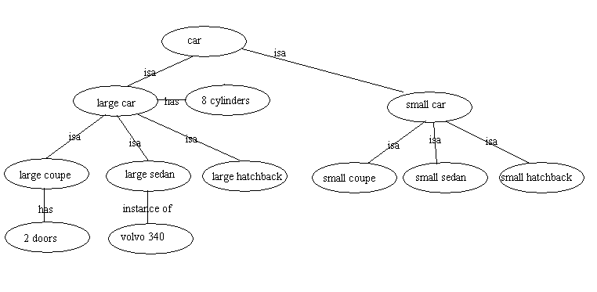

Question 3
- Design a CBR system to select an exercise regime for a person. Describe at least 5 cases and the case comparison mechanism.

[15 marks]

Each case 5 marks

Features 5 Marks

Comparison mechanism 5 Marks

Sample Answer:
Blah blah
- What would make someone an expert in this domain?

[8 marks]

They have solved lots of problems in this domain 3 Marks

5 Marks

5 Marks

Sample Answer:
Blah blah

- How is a new case compared to the case base?
[10 marks]
Markers Note: I asked this in May 2002. I'm intentionally asking it again because people did so poorly on it and so few answered it.

Distance Measurement (dimensionality and cosine for full marks) 5 Marks

Comparing number of features that are the same 2 Marks

Weighting features 2 Marks

Putting feature values in the same space (binary vs. real) 1 Marks
Answer:
A simple way of comparing cases is to use a distance measurement. Each feature is compared. If all features are in a continuous format this is straight forward, however in this case a measurement for each scalar value will be needed. E.g. football=1, hockey=2, running=3. Some features may be more important so their weights should be increased in the measurement. For example symptom is probably more important than gender for this case.

An alternative is to simply compare the number of features that are the same.

Question 4

- For most expert systems, it is crucial for the system developer to interact with a domain expert. What is the process called, and what can the domain expert be used for?

[11 marks]

Knowledge Engineering 3 Marks

Deciding on system type 2 Marks

Feasibility 2 Marks

Rules or cases 2 Marks

System Verification 2 Marks

Sample Answer:
Blah blah

- What questions would you ask if you were trying to design a system that a child could use to do simple arithmetic?

[15 marks]

How do children learn arithmetic 5 Marks

What are the stages they go through 3 Marks

What are the crucial data members 3 Marks

What are the rules children follow 2 Marks

Are there rules or cases for teaching 2 Marks

Markers Note: Other good answers are acceptable

Sample Answer:
Blah blah

- If you were to implement a rule based system to do simple arithmetic, what type of chaining would you use? Why? Feel free to state any assumptions you have made.

[7 marks]

Markers Note: really any type is defensible. The important bit is to make the choice based on the domain

Choice based on domain 3 Marks

Good reasons for choice 4 Marks

Sample Answer:
Blah blah

Question 5

- Write a function (in any language or in psuedo-code) that evaluates a series (array or list) of boolean variables and returns whether the AND of them is true or false.

[12 marks]

True and False returns 3 marks

Handles and for 2 2 marks

Deals with more than 2 2 marks

Works 5 marks

Sample Answer:
Boolean MyAnd (Variables[] boolean, length int)
{
for (int I=0; I++; I<length)
if (!Variables[I]) return False;
return True;
}

- Draw Frames (or Schankian Scripts) for going to a restaurant and for going to a fast food restaurant. Please show the relationship between the two.

[11 marks]

Frame structure 3 Marks

Good slots 3 Marks

Hierarchy 3 Marks

Default values included 2 Marks

Sample Answer:
Blah blah

- Logic and frames are symbolic representations. Is there any domain that is not appropriate for symbolic representation. If not, why not? If so, give an example and explain why it is not appropriate.

[10 marks]

Markers Note: this can be answered either way but the following points are relevant to either answer

Continuous domains and arbitrary digital approximation 4 Marks

Complex domains like vision 3 Marks

Efficiency of representation 3 Marks

Sample Answer:

Blah blah

